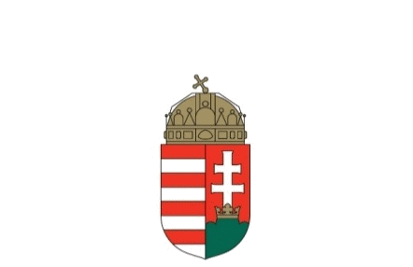

The Ministry of Foreign Affairs and Trade of Hungary

DRAFT AGENDA

Council of Europe Day
∗Opportunities for political participation of national minority youth∗
May 9, 2023

Location: European Youth Centre in Budapest - EYCB (1 Zivatar Street, Budapest 1024)

Time | Program | Technical details
10:00 am | Welcoming remarks  Mr Ferenc Kalmár, Special envoy of the Minister for Developing Neighbourhood Policy of Hungary, Ministry of Foreign Affairs and Trade  Mr Bálint Molnár, Director, European Youth Centre in Budapest  Mr Björn Berge, Deputy Secretary General, Council of Europe  Opening ceremony  Mr Péter Sztáray, State Secretary for Security Policy and Energy Security, Ministry of Foreign Affairs and Trade of Hungary  Mr Zsolt Németh, Chairman of the Foreign Affairs Committee, Hungarian National Assembly | Public to the press
10:30 am | Keynote presentations  Dr. Wolfram Bechtel, Secretary of the Steering Committee on Anti-Discrimination, Diversity and Inclusion (CDADI), Council of Europe  Dr. Adrienn Tóth-Ferenci, Hungarian delegate in the CDADI  First panel: opportunities for the political participation of Hungarian youth in the neighbouring countries  Participants:  Mr László Gubík, Association for Common Goals, Via Nova – Slovakia  Mr Dávid Simon, Youth section of the Transcarpathian Hungarian Cultural Association – Ukraine  Ms Dóra Szilágyi, Vice-president, Youth section of the Democratic Alliance of Hungarians in Romania  Mr Attila Edmár, Hungarian Youth Conference – Hungary  Moderator:  Dr. Gergő Kocsis, Head of UN Department, Ministry of Foreign Affairs and Trade of Hungary
12:30 pm | Lunch Break
1:30 pm | Keynote presentations:  Ms Pia Šlogar, co-chair of the Programming Committee on Youth, and External Representative of Youth of European Nationalities (YEN) and member of the Advisory Council on Youth  Mr Imre Ritter, Chairman of the Committee on National Minorities in Hungary, Hungarian National Assembly  Second panel: Political participation of national minority youth in Hungary  Participants:  Ms Blanka Jordán, President, German Youth Association in Hungary  Mr Milán Kovács, Croatian National Self-Government in Hungary  Mr Bence Szeljak, President, Slovak Youth Association in Hungary  Mr Domokos Péter Kovács, presidential representative of the National Youth Council  Moderator:  Mr Richárd Tircsi, Head of Department, Department of Nationalities, State Secretariat for Church and Nationality Relations, Prime Minister's Office
3:30 pm | Closing remarks  Mr Ferenc Kalmár, Special envoy of the Minister for Developing Neighbourhood Policy of Hungary, Ministry of Foreign Affairs and Trade

